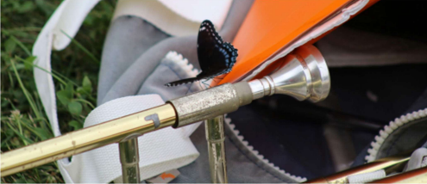
Troy Athens Band Camp Information 2021

Camp Dates
Jul 26th-30th (Thu-Sat): Mini-Camp at Troy Athens HS.
Aug 2nd – Aug 7th (Mon-Sat): Band Camp at Echo Grove campground.
Mini-Camp at Athens HS
Mini-Camp is mandatory for ALL marching band members.
This includes the Aux Guard, even if you are not going to Echo Grove camp.
Band Camp at Echo Grove
We then spend the following week, Mon – Sat, at the Echo Grove campground. Students will take a bus Monday morning to camp.
Camp will end on Saturday with a performance on the practice field. Parents are invited to attend the performance at camp.
Parents are responsible for providing transportation home from camp. Camp is usually optional for middle school members of the Aux Guard. For 2021, Aux Guard WILL NOT attend band camp. Camp is mandatory for all high school participants.
Contact Information
Camp Chairperson/Camp Health Officer
Gina Miller/Joan Van Kampen
248.703.1355/ 248.840.3112
ginamillertabb@gmail.com / JoanVanKampen28@gmail.com

Band Camp Calendar

The Band Camp calendar can be found here - https://www.troyathensbands.com/calendar.html
The calendar includes all scheduled activities.
Meal calendar events include the menu for that meal including vegetarian options.
Directions for syncing the camp calendar to your phone can be found on the calendar page of the Troy Athens Bands website located here: https://www.troyathensbands.com/calendar.html

Camp Logistics
Mini-Camp Logistical Plans for Parents TBD
Camp Drop Off Logistical Schedule TBD
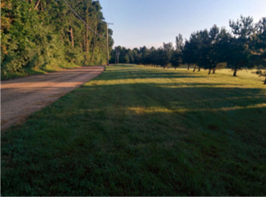
Parents are responsible for ensuring that their children have a ride home.
For GPS navigation to the practice field, enter this address: 1150 Camp Rd, Leonard, MI 48367
The actual address for the Echo Grove Campground will take you past this location.
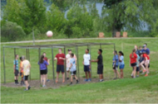
Additional Information
Air Conditioning at Echo Grove
The following buildings are air conditioned:
Dining Hall / Gym and Welcome Center
Note that Seldon, the boys’ cabin, is now air conditioned, but we do not plan on utilizing this option since we spend very little time in the cabins during the day and it can get chilly at night.
Bus to Camp
Place all luggage in the staging area near the buses. Students may take a backpack size bag on the bus with them. Adults assigned to each bus will load the luggage into the underside of each bus.

Cars
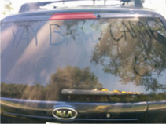
Students are not allowed to have
personal vehicles at camp.

Checking In or Out of Camp
Every student who comes or leaves
from camp must be signed out or
signed in. Any adult can sign in a
student to camp.
Only approved adults can sign out a
student out of camp. Parents are
allowed to sign out their children.
Note: Noncustodial parents may be
removed from the approved list. If you
need to ensure that noncustodial
parent is not allowed to sign out a child from camp, then please contact the Band Camp Chairperson.
Other adults may be added to the approved adult check out list for a student. The names of other approved adults for student check out must be submitted in writing to the Camp Chairperson.
Every person who checks out a student from camp (including parents), must show photo ID. The name on the ID must match that on the approved check out roster.
Cabins
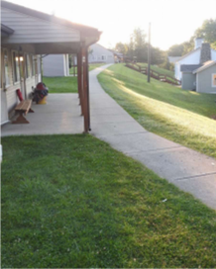
The girls stay in three cabins named Oak, Pine, and Willow. The boys stay in a single larger cabin named Seldon. All cabins have windows with screens. The girls cabins are not air conditioned. The boys’ cabins have air conditioning, but we are not expecting to utilize it. All cabins have electricity, but the number of outlets is limited. Bring a power strip if you plan to plug in your electronic devices. Fans are allowed and recommended. The cabins all have running water & modern bathrooms with showers. We are responsible for the cleanliness of our cabins. We will all clean up after ourselves at camp.

Drinking Containers
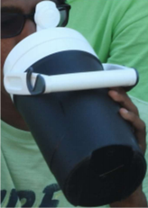
Bring containers to hold water and Gatorade.
Many students bring 2 containers.
1 water container & 1 Gatorade container.
Clearly label your containers with:
Your Name.
Your Section.
Your Preferred Flavor for the Gatorade container.
(Color name is fine).
Gatorade preference can be changed at any
time at camp. Just cross off the old preference
and write down the new preference.
Golf Cart
The TABB golf cart will be used at camp.
Students are not allowed to drive the golf cart.
The cart is used for transporting heavier items:
Gatorade (5 gallon and 1 gallon containers)
Water
Medical Kit and Medicine Lock Box
Internet Access
WiFi access is available in the cafeteria and the welcome center. These access points are password protected. The WiFi password will not be publicly posted. The WiFi password will be provided to everyone who asks for it at camp.
Lights Out & Quiet Hours
10:15 PM Students must be in their cabins.
10:30 PM Lights Out.
6:30 AM Reveille (the morning wakeup call).
Locations for Band Camp
Mini-Camp will be located at Troy Athens High School.
Full Band Camp will be located at Echo Grove Camp in Leonard, MI. Echo Grove is a 21-mile drive from Troy Athens HS.
More information about Echo Grove can be found on their site here: http://www.echogrove.org/

Medications While at Camp
State licensing requires that all medications be held by our Camp Health Officer. Medications must remain locked when not being dispensed. Deliver your medication to the Camp Health Officer on Monday morning when dropping off students for camp. Medications must be properly labeled and in their original containers. Only send enough medication to last through the week at camp. The Health Officer will oversee the administration of all medications at camp. Most medications are administered prior to each meal & during the evening free time (around 9:00 PM).
Menu
The menu (including vegetarian) is available for the entire week at camp. The calendar entry for each meal includes the menu for that meal. See the Band Camp calendar for each meal.
Money
No cash is required while at camp. In addition to the three main meals, some snacks are planned, and students are allowed to bring their own snacks. Snacks may also be purchased at the camp store. If anyone chooses to bring cash to purchase snacks, $20 should be plenty.
OFF Limits Areas
Specific sections of Echo Grove Campground are reserved for our use. Other sections are reserved for other groups.
Davison High School Marching Band will also be at Echo Grove at this time. No one is allowed to enter cabins and buildings not reserved for our use. The house at the edge of our practice field is private property. Do not cut across the lawn of this house. Walk on the side of the road until reaching the field.
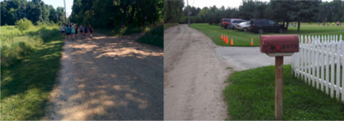The Echo Grove Map near the end of this document indicates all areas that are OFF limits.

Phones (and other electronic devices - including laptops)
Students are allowed to bring phones.
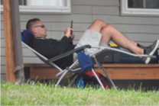
Cell phone coverage at camp is not guaranteed.
Some people have reported excellent cellular
service at camp. Others have reported
poor or spotty cellular service at camp.
Students are responsible for their electronics.
The number of outlets in each cabin is
limited. Bring a power strip if you plan to
plug in electronic devices.
Pictures
Pictures from camp will be upload as time allows and
can be found here: https://troyathens.smugmug.com/

Policies for Camp
Band Camp will be run in accordance with our published policies:
https://www.troyathensbands.com/band-camp-policies.html
Pool
We have scheduled pool times as posted on the Band Camp Calendar. All students are welcome and invited to use the pool during our scheduled times. The pool has a shallow area (around 3’ deep) and a deeper area. Everyone must pass a short swim test to use the deep end of the pool. Wristbands will be administered to everyone passing the swim test. Keep your wristbands on throughout the week for continued access.
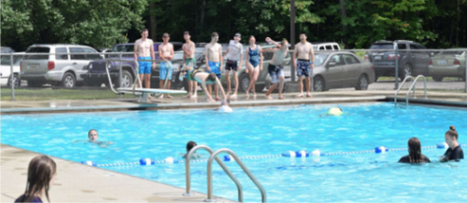
Porta-John
There is a single-person portable toilet unit located at the practice field.

Questions or Issues During Camp
You are welcome to contact the Camp
Chairperson and Camp Health Officer
any time before or during camp with any
questions or concerns. During camp, text
messaging is the best way to get a quick
response. There will be an in-person parent
meeting during minicamp to cover the
camp details and answer any questions you
may wish to ask in person.
Their contact information is on the front
page of this document.
Responsible Students
Students are responsible for all their possessions while at camp. They must keep track of their money, phones, chargers, etc. If items are lost, we will do our best to find them. However, lost money has rarely been recovered.
Seniors
Bring the extra gear that you will need for your special activities. The senior prank must be approved by the Camp Chairperson during Mini-Camp. Bring everything required for your Senior Prank. Bring a tarp for sleeping outside.
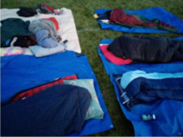
Note: Dew forms from above. Keep your tarp over you (not under you) if you wish to wake up dry in the morning.
Skits
Each section will write and perform a skit. Every group must get approval for their skit idea from the Camp Chairperson.

Snacks
Students are welcome to bring snacks. Many kids will bring plastic containers filled with snacks.
No nuts. We have severe nut allergies in our group.
Note: Containers less than 10.5" tall will fit under the beds.
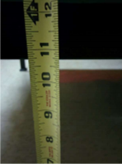
Special Diet Requirements
If you have special diet requirements, you should complete and submit the band camp form #7.
Spirit Days
The Drum Majors determine the Spirit Days for camp. This information will be given to your student.
State License
The Troy Athens Band Camp is licensed through the State of Michigan as a program camp. A state inspector will visit us at camp to ensure that we are in compliance with all the applicable regulations. License Number: CR630393713
Store at Camp
Froggies is the camp store. It will be open at the following times: 4:00 PM – 5:00 PM on Mon-Fri. and 8:30 PM – 10:30 PM on Mon-Thu.
Students are responsible for their own money.

Summer School
Conflicts with Summer School should be discussed with Mr. Cable. Students are encouraged to attend Summer School sessions that do not conflict with the dates for Band Camp.
Students that have approved Summer School conflicts should contact the Camp Chairperson to work out logistics between both events, which may include checking students in and out of camp.

Sun Exposure
Students will be outside for significant periods of time during camp. Sun protection is required.
Bring enough sunscreen.
Bring hats and sunglasses.
Additional sun protection is recommended. Cooling scarves are useful. .

Visitation
Parent visitation to camp is not permitted.
Visitor Exception: Anyone bringing snacks or treats for the entire group at camp may be allowed to come up during the week at Echo Grove in order to drop off snacks. This must be scheduled ahead of time.
Water
Every student MUST bring 2 gallons of unopened water to minicamp. This water is used to make Gatorade throughout the week at Echo Grove. Water should be brought with you on the final day of minicamp. Drop off the water in the shade of the trees near the stadium. Water will be loaded into a band trailer & brought with us to camp. If you forget to bring the water to minicamp, then you will need to bring it with you on the bus (please do not forget).

Weather
Come to camp prepared for all weather conditions. We will alter the schedule for significant weather events. But be prepared: the nights can be chilly, the days can be hot and we may be outside in light rain.

Echo Grove Map

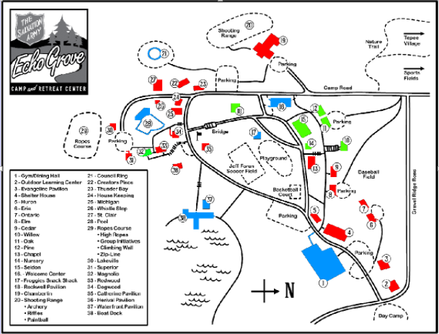

Green = Reserved exclusively for Troy Athens Marching Band use. The Sports Field is also reserved for our exclusive use
Blue = Public or shared use buildings.
Red = Reserved for other groups. OFF Limits to us.

Packing List
Required Items
___ Pants, jeans, shorts
___ Athletic shorts (for rehearsals – no jean shorts)
___ Black shorts for guard members
___ T-shirts, sport shirts, knit tops
___ Socks, underwear, pajamas
___ Sweatshirt or jacket
___ Swimsuit (girls are required to wear dark t-shirt over 2-piece suits)
___ Shoes (2 pairs, suitable for marching)
___ Spirit Days items
___ Shower shoes / flip flops (for shower)
___ Toiletries
___ Tissues
___ Insect repellent
___ Sunscreen
___ Gold Bond Powder
___ Instrument (in good playing order)
___ Lyre & Flip Folder (Important)
___ Marching music
___ Reeds, valve oil, etc.
___ Music stand (5th grade style is OK, label both pieces of your stand)
___ Pencil and paper
___ Hat (needed for sun protection)
___ Raincoat or poncho
___ Sunglasses
___ 2 gallons of new bottled spring water (bring to Minicamp on Saturday)
___ Water bottle or small thermos
___ Sleeping bag or sheets & blankets (prepare for cold nights)
___ Pillow
___ Towels and washcloths
Optional Items
___ Money
___ Phone (with charger and power strip)
___ Flashlight and extra batteries
___ Games
___ One 6/8 pack of Gatorade, 20-24 oz
___ Fan with extension cord (and power strip)
___ Laundry or duffel bag
END OF DOCUMENT

